**USA_CRIME ANALYSIS PROJECT-1**

1)HIVE Program to calculate the number of cases investigated under each FBI code

Ans:

* Creating a database and using it .then create an external table named all_crimes with all the datasets given.
* Loading the data from the file in to table created.
* Calculating the no.of cases investigated under each fbi code by using group by command.

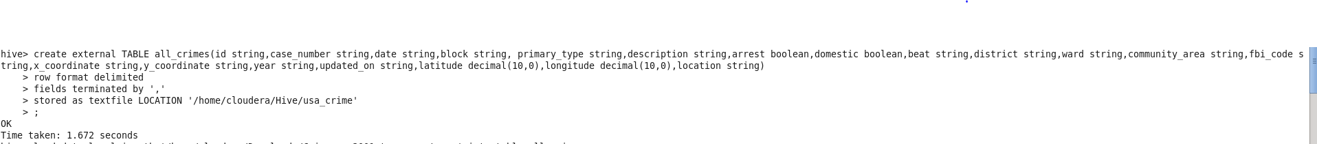

 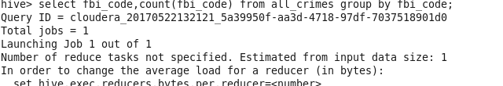

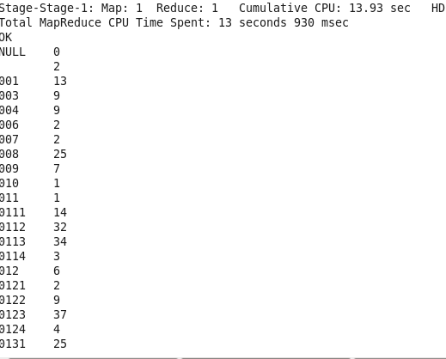

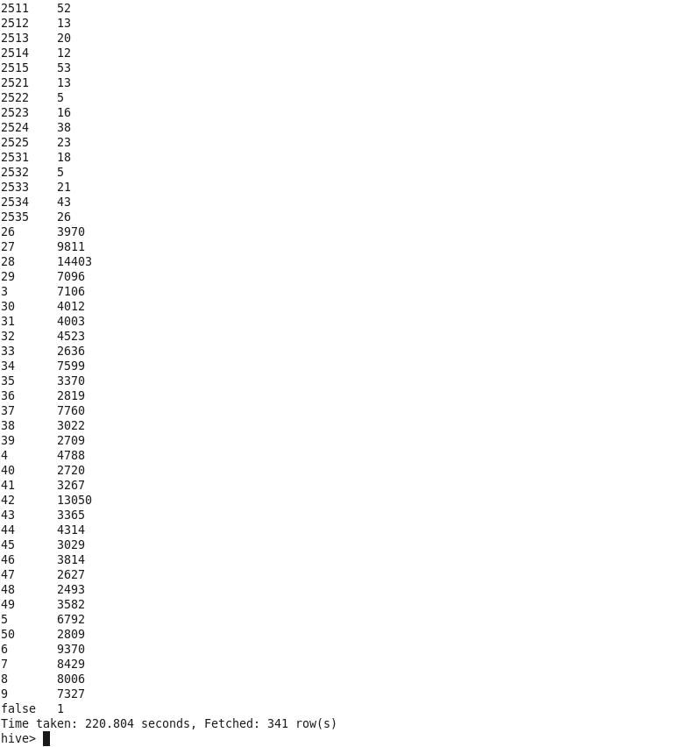

2. HIVE program to calculate the number of cases investigated under FBI code 32.

* Calculating the no.of cases investigated under fbi code=32 by using where clause and group by command.

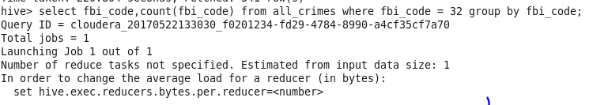

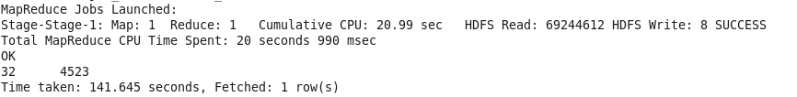

3. HIVE program to calculate the number of arrests in theft district wise.

Use select and where clause and group by and retrieve the primarytype theft and district theft and the number of arrest in district

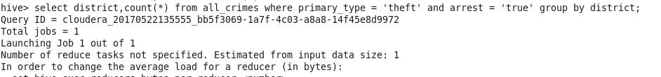

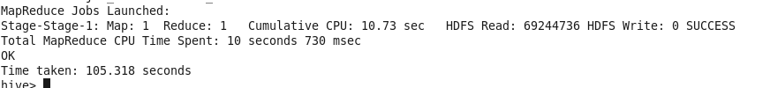

4. HIVE program to calculate the number of arrests done between october 2014 and october 2015.

* Calculate the number of arrests done between october 2014 and october 2015 BY using between operator and groupby clause.

